MARYAM SAJID
Session: 2023 - 2027 | Department OF INFORMATION TECHNOLOGY
S23BINFT1M01068
Land management system
Software Requirements Specification Document

Revision History
Date | Description | Author | Comments
 | Version 1 | MARYAM SAJID

Document Approval
The following Software Requirements Specification has been accepted and approved by the following:
Signature | Printed Name | Title | Date
 | Mr. Faisal Shahzad | Supervisor, BSIT

Table of Contents

1. Introduction 1
1.1 Purpose 1
1.2 Scope 1
1.3 Definitions, Acronyms, and Abbreviations. 2
1.4 References 2
1.5 Overview 2
2. The Overall Description 3
2.1 Product Perspective 3
2.1.1 Operations 4
2.1.2 Site Adaptation Requirements 4
2.2 Product Functions 5
2.3 User Characteristics 5
2.4 General Constraints 6
2.5 Assumptions and Dependencies 7
3. Specific Requirements 7
3.1 External Interface Requirements 8
3.1.1 System Interfaces 8
3.1.2 Interfaces 8
3.1.3 Hardware Interfaces 8
3.1.4 Software Interfaces 8
3.1.5 Communications Interfaces 9
3.2 Functional Requirements 9
3.2.1 <Functional Requirement or Feature #1> 9
3.2.2 <Functional Requirement or Feature #2> 10
3.2.3<Functional Requirement or Feature #3> 11
3.3 Use Cases 12
3.3.1 Use Case #1 12
3.3.2 Use Case #2 12
3.3.3 Use Case #3 12

3.4 Classes / Objects 16
3.4.1 <Class / Object #1> 16
3.4.2 <Class / Object #2> 16
3.5 Non-Functional Requirements 17
3.5.1 Performance 17
3.5.2 Reliability 17
3.5.3 Availability 17
3.5.4 Security 17
3.5.5 Maintainability 17

3.6 Inverse Requirements 18
3.7 Logical Database Requirements 18

1. Introduction
This SRS defines the Smart Property Portal, a web-based real estate marketplace designed to streamline the buying, selling, and renting of properties through a modern and user-friendly platform. The system enables buyers to search and filter verified listings, explore detailed property information, and contact sellers or agents directly. Sellers and agents can add and manage their listings, while an admin moderates all content through an approval workflow to ensure authenticity and quality before any property becomes publicly visible.
The core problem addressed by this project is the lack of verified information and structured data within many localized property listings. The Smart Property Portal solves this by enforcing strict moderation and requiring structured inputs (city, area, price, type) for all listings. Built upon a robust and efficient Django backend, a dynamic React.js frontend, and utilizing an SQLite database for persistent data storage, the platform emphasizes security, scalability, and high performance. It includes essential modules for user management, listing creation, search filters, agent profiles, an Admin Dashboard, and CMS pages. This SRS outlines the system’s architecture, functionality, interfaces, constraints, and requirements to guide development, testing, and future enhancements of the Smart Property Portal.

1.1 Purpose
The purpose of this SRS is to define a real-estate listing platform where Sellers/Agents can post properties and Buyers can search verified listings. The system ensures that every property added by a seller goes through an admin-controlled approval workflow before becoming public, reducing misinformation and improving listing quality. It provides structured listing fields, secure authentication, and a clean search experience to make property browsing reliable and efficient.

1.2 Scope
The software product to be produced is the Smart Property Portal, a web-based real estate marketplace.
The system allows Sellers/Agents to:
- Add properties with complete details and multiple images.
- View and manage (edit/delete) their own listings.
- Manage user profiles.
The system allows Admins to:
- Manage approvals for all listings (Approve/Reject).
- Manage users (Ban/Activate).
- Manage site content (Cities, Areas, Categories, CMS Pages).
The system allows Buyers to:
- Search properties by city, area, price, type, and purpose.
- View full details (images, map, description, seller info).
- Contact Sellers/Agents via call, WhatsApp, and inquiry form.
The platform will not include: payment gateways, booking modules, chat systems, or live location verification in this version. All core data is stored in SQLite, authentication uses Django sessions, and only approved listings appear publicly.

1.3 Definitions, Acronyms, and Abbreviations.
Term | Definition
SRS | Software Requirements Specification
CMS | Content Management System (used by Admin for static pages, cities, etc.)
API | Application Programming Interface (specifically the REST APIs exposed by the Django backend)
Buyer | Any public user searching for properties.
Seller/Agent | An authenticated user who posts property listings.
Admin | An authorized user with moderation and system management privileges.
Pending | Status assigned to a new listing awaiting Admin approval.
Approved | Status assigned to a listing that is publicly visible in search results.
CSRF | Cross-Site Request Forgery
HTTPS | Hypertext Transfer Protocol Secure

1.4 References
- IEEE Recommended Practice for Software Requirements Specifications (IEEE Std 830-1998).
- Django Documentation (Specific version used).
- React.js Documentation (Specific version used).

1.5 Overview
Section 2 provides the overall description, context, constraints, and user characteristics of the Smart Property Portal. Section 3 details the specific requirements, including external interfaces, detailed functional requirements, use cases, object definitions, and measurable non-functional requirements that guide the development process.

2. The Overall Description
This section describes the general factors that affect the Smart Property Portal and its requirements, providing a necessary background and context for the specific requirements defined in Section 3. In essence, this section tells the requirements in plain English for the consumption of the customer, focusing on the product's place in the market and how it must operate.

2.1 Product Perspective
The Smart Property Portal is a new, independent system and is designated as a greenfield development. It serves as a foundational release with a primary goal of creating a verified, trustworthy listing platform. The system operates as a black box in relation to external entities, handling all core logic, data storage, and user interactions internally. he Smart Property Portal is a standalone, self-contained web application. It is not a component of a larger system, nor is it designed to interface with or depend upon external enterprise systems (such as corporate ERPs, accounting systems, or advanced GIS/mapping APIs).
The system's only external dependency for non-core features is the use of a simple web service or standard protocol for:
- Map Embeds: For displaying approximate property locations (Dependency: Simple iframe or embed code).
- Email Service: For password reset links and seller inquiry/notification delivery (Dependency: Standard SMTP connection).

Block Diagram: System Context and Interfaces

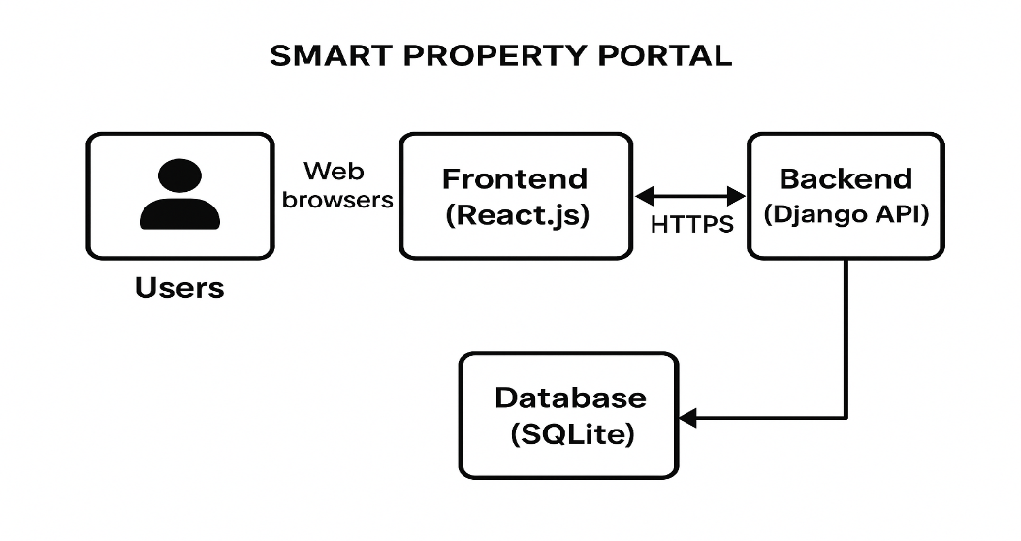

2.1.1 Operations
This section specifies the various modes of operation and necessary data management procedures that impact the software design and deployment of the Smart Property Portal.
1. Normal Modes of Operation (Interactive Operations)
- Public Access Mode: Available 24/7. Buyers interact with the public search, view property details, and utilize contact forms. This mode requires continuous uptime and low latency (NFR-1).
- Authenticated User Mode: Available 24/7. Sellers/Agents manage their listings, upload images, and update profiles, requiring secure session management (NFR-3).
- Administrative Mode: Available 24/7 to authorized Admins. This involves interacting with the Django Admin interface to review listings (Pending/Approved/Rejected), manage static CMS content, and control user statuses (Ban/Activate).
2. Periods of Unattended Operations (System Tasks)
- The system is designed for continuous operation. There are no planned periods of complete system downtime required for operational tasks.
- Image Processing: Unattended tasks include asynchronous server-side processing of uploaded images (resizing, optimization, thumbnail generation) to ensure fast loading times (NFR-1).
- Email Queuing: Outgoing emails (notifications, inquiries) are queued and sent asynchronously by the backend to avoid delaying interactive user experience.
3. Data Processing Support Functions
- Listing Status Transition: The core data function is the server-side logic controlling the status transition (Pending -> Approved or Rejected), which is a deterministic process triggered by the Admin (FR-09).
- Search Indexing: To maintain rapid search performance (NFR-1), the system must automatically update the search index whenever a listing status changes from Pending to Approved.
- Data Integrity Checks: Scheduled background tasks may be implemented post-deployment to periodically verify the consistency of foreign key relationships between Property, Image, and User records.
4. Backup and Recovery Operations
- Backup: A separate, routine server operation (outside the application software itself) shall be responsible for performing daily incremental backups of the SQLite database and the media storage directory (containing property images). This usually occurs during low-peak usage hours (e.g., midnight to 3:00 AM).
- Recovery: A formal, documented procedure must exist to restore the database and media files from the most recent backup in the event of catastrophic data loss, ensuring minimal data loss (MTD).

2.1.2 Site Adaptation Requirements
The system requires no modifications to the customer's physical work area. Software-specific adaptation requirements include:
- Database Setup: The system requires a clean installation of the SQLite relational database to store all application data, users, and listings.
- Server Environment: The hosting environment must be capable of running the Django backend framework, handling static file serving, and providing secure HTTPS access.

2.2 Product Functions
The core functionality of the Smart Property Portal is defined by three primary user roles:
- Buyer Functions: Search and filter listings by key criteria (city, area, price), view detailed property information, and initiate contact with the seller.
- Seller/Agent Functions: Securely register, add new properties with rich data and multiple images, and manage (edit/delete) their submitted listings.
- Admin Functions (Moderation & Management): Control the property lifecycle (Approve/Reject), manage system-wide data (Cities, Users), and update core site content (CMS pages).

2.3 User Characteristics
User Role | Goal/Task | Educational/Experience Level | Impact on Design
Buyer | Find a verified property quickly. | Basic web literacy, moderate comfort with search filters. | Intuitive search bar, responsive design, clear contact call-to-actions.
Seller/Agent | List a property with high quality data. | Familiarity with online forms, attention to detail required for data input. | Structured forms, robust input validation, clear feedback on listing status (Pending, Approved, Rejected).
Admin | Ensure content authenticity and manage users. | Moderate technical expertise, familiarity with database-driven content management (e.g., Django Admin). | Simple table layouts for review, clear Approve/Reject workflow buttons.

2.4 General Constraints
(1) Regulatory Policies | The system must comply with all relevant local data privacy regulations regarding the collection and storage of user contact information (emails, phone numbers). | Requires robust access controls (Privacy NFR-10), secure hashing of passwords, and clear consent processes during registration.
(2) Hardware Limitations | The system is designed for commodity web hosting; it cannot rely on specialized or high-performance hardware. | Prevents the use of resource-intensive processes like complex real-time GIS services or heavy batch processing.
(3) Interface to other applications | The system is forbidden from integrating with any external applications (e.g., payment APIs, social media logins, advanced mapping APIs) in this version (DC-7). | All data management, authentication, and core business logic must be self-contained within the Django application.
(4) Parallel operation | The system must support thousands of simultaneous read operations (search and viewing) but is not required to support highly parallel write operations, as listing submission and administration are low-frequency tasks. | Focus performance optimization on database reads (caching, query optimization) rather than complex transaction handling.
(5) Audit functions | Admin actions (Approve, Reject, Ban/Activate User) must be traceable. | Requires implementing a basic logging mechanism within the Django Admin to record the time, user, and nature of the action performed.
(6) Control functions | Listing control must be role-based: only Sellers can create or edit their own pending listings; only Admins can control the status (Approve/Reject) of any listing. | Requires strict server-side authorization checks on all API endpoints related to listing creation and modification.
(7) Higher-order language requirements | The use of the specified technology stack (Python/Django, JavaScript/React.js) is mandatory (DC-1). | Prohibits the use of other languages (e.g., PHP, Java, Ruby) for core system development, ensuring uniformity.
(8) Signal handshake protocols | All client-server communication must use standard HTTP/S RESTful protocols. | Precludes the use of persistent connection protocols (e.g., WebSockets) or proprietary handshake methods, reinforcing the stateless nature of the application.
(9) Reliability requirements | Listings marked 'Approved' must be visible 100% of the time, barring a full system failure (NFR-4). | Requires robust database query design and efficient error handling to prevent data visibility issues.
(10) Criticality of the application | The primary critical function is the integrity of listing data and user authentication. | System failure must not result in data corruption or unauthorized access (NFR-3).
(11) Safety and security considerations | All sensitive data transfer must use HTTPS, and form submissions must be protected by CSRF tokens. | This impacts every network transaction and form design across the entire React frontend and Django backend.

2.5 Assumptions and Dependencies
- Assumption: Admin users will manually check the authenticity of listings before approval (no automated verification).
- Assumption: The Seller/Agent will provide accurate details during the listing submission process.
- Dependency (DC-9): The map feature relies on a simple embed-based mapping service (e.g., Google Maps embed) and does not require complex GIS services.
- Dependency: The system relies on a working email service configured on the server for password resets and seller notifications.

3. Specific Requirements
This will be the largest and most important section of the SRS. The customer requirements will be embodied within Section 2, but this section will give the D-requirements that are used to guide the project’s software design, implementation, and testing.
Each requirement in this section should be:
- Correct
- Traceable (both forward and backward to prior/future artifacts)
- Unambiguous
- Verifiable (i.e., testable)
- Prioritized (with respect to importance and/or stability)
- Complete
- Consistent
- Uniquely identifiable (usually via numbering like 3.4.5.6)
Attention should be paid to the carefully organize the requirements presented in this section so that they may easily accessed and understood. Furthermore, this SRS is not the software design document, therefore one should avoid the tendency to over-constrain (and therefore design) the software project within this SRS.

3.1 External Interface Requirements

3.1.1 System Interfaces
The system is entirely self-contained. Therefore, the requirement is: The system shall not require interfaces with any external operational systems or APIs for core listing, search, or authentication functionality.

3.1.2 Interfaces
The system shall utilize a modern, responsive web-based Graphical User Interface (GUI) to provide seamless interaction for all user roles across desktop and mobile browsers.
- UI-3.1.2.1: The public interface (Buyer view) shall adhere to principles of clean, intuitive design, focusing on search efficiency and clear presentation of property details (Traceable to Use Case 3.3.2).
- UI-3.1.2.2: The Seller/Agent dashboard shall provide a clear overview of their current listings categorized by status (Pending, Approved, Rejected).
- UI-3.1.2.3: The Admin panel shall be a secure, table-based interface designed for high-efficiency moderation and management of users and content.

3.1.3 Hardware Interfaces
The system shall have no direct hardware interface requirements. The application relies solely on standard client hardware (PC, mobile device) and web-hosting servers..

3.1.4 Software Interfaces
Name | Mnemonic | Version No. | Purpose | Traceability
Django | Backend FW | Specify Version | Core application logic, REST API provision, and session management. | DC-1
SQLite | DB | Specify Version | Relational data storage for all application data. | DC-1
React.js | Frontend FW | Specify Version | Dynamic user interface for Buyer and Seller/Agent roles. | DC-1
Email Service | Standard SMTP | N/A | Password reset and Seller notification delivery. | Dependency 4

The application requires interaction with the following foundational software components

3.1.5 Communications Interfaces
This subsection details the required protocols for data transfer and communication channels.
- CI-3.1.5.1 (Security & Transport): All client-server communication MUST be secured using the HTTPS protocol to ensure data confidentiality during transfer (Traceable to General Constraint 2.4(11)).
- CI-3.1.5.2 (Protocol): The data exchange shall exclusively utilize RESTful API endpoints over HTTPS, maintaining the stateless nature of the application (Traceable to General Constraint 2.4(8)).
- CI-3.1.5.3 (External Links): Contact options using WhatsApp shall utilize the standard wa.me URL protocol link structure.
.

3.2 Functional Requirements
The Functional Requirements are organized by core system features, detailed using the mandatory sub-section format

3.2.1 Functional Requirement or Feature #1

3.2.1.1 Introduction
This feature covers the complete lifecycle of a property listing from the Seller's perspective, ensuring listings are rich in detail and images, and immediately placed into the Admin approval queue (UC-01).

3.2.1.2 Inputs
- Listing Details: Title (max 100 chars), Price (numeric), City (Dropdown), Area (Dropdown), Purpose (Radio: Sale/Rent), Property Type (Dropdown), Size (Numeric), Bedrooms (Numeric), Bathrooms (Numeric), Description (Text, max 2000 chars), Map Location (Embedded iframe HTML/text).
- Images: Multiple JPEG/PNG files (Max 5MB each, max 10 images per listing).

3.2.1.3 Processing
- Input Validation (FR-3.2.1.3.1): Server-side and client-side validation of all mandatory fields (Title, Price, Location, Type, Purpose) shall occur upon submission (Traceable to General Constraints 2.4).
- Image Processing (FR-3.2.1.3.2): Images shall be uploaded to Django's media storage, validated for format/size, and associated with the listing.
- Status Assignment (FR-3.2.1.3.3): The system SHALL create the Property record with the status field explicitly set to 'Pending' (Traceable to DC-3).
- Ownership Link (FR-3.2.1.3.4): The createdByUserId shall be automatically set to the currently logged-in Seller/Agent, enforcing ownership control (Traceable to Control Functions 2.4(6)).

3.2.1.4 Outputs
- Confirmation message: "Listing submitted for Admin review."
- The Seller's dashboard displays the new listing with a Pending status badge.

3.2.1.5 Error Handling
- If validation fails, the system returns clear error messages mapped to the specific input field (Traceable to Useability USE-4).
- If an image upload fails, the system shall reject the invalid image and display a specific file error message.

3.2.2 Functional Requirement or Feature #2
3.2.2.1 Introduction This feature allows Buyers to find properties based on geographical and commercial criteria, ensuring only quality, approved listings are returned (UC-02).
3.2.2.2 Inputs
- Search Form Inputs: City, Area, Purpose, Property Type, Min/Max Price Range.
- Sorting Criteria: Latest, Price Low to High, Price High to Low.
- Pagination Request: Page number (default 1).
3.2.2.3 Processing
- Query Construction (FR-3.2.2.3.1): The backend shall build a database query incorporating all active filters.
- Approval Filter (FR-3.2.2.3.2): The query MUST include a WHERE status = 'Approved' condition to prevent unverified listings from appearing (Traceable to Data Integrity NFR-4).
- Execution & Sorting (FR-3.2.2.3.3): The query shall be executed, and results sorted as requested.
- Pagination (FR-3.2.2.3.4): Results shall be paginated (e.g., 10 results per page) before being returned to the frontend.
3.2.2.4 Outputs
- A JSON response containing the list of matching approved properties, including pagination metadata (total pages, current page).
- On the frontend, a responsive, paginated list of property search results is displayed.
3.2.2.5 Error Handling
- If the database connection fails, the system displays a generic error: "Search service temporarily unavailable."
- If no matching properties are found, the system displays: "No properties found matching your criteria. Try a broader search." (Traceable to Useability USE-8).
- Invalid or non-numeric filter inputs (e.g., price range) must be rejected with a validation error.

3.2.3 Functional Requirement: Admin Moderation & Approval Workflow
3.2.3.1 Introduction This feature enables the Admin to review submitted listings, control public visibility, and notify the Seller/Agent of the decision (UC-03).
3.2.3.2 Inputs
- Admin Login Credentials.
- Action Button Click: Approve or Reject.
- Text Input: Rejection remarks (optional for Approve, mandatory for Reject).
3.2.3.3 Processing
- Pending Retrieval (FR-3.2.3.3.1): The system shall allow Admin to access and fetch all listings where status = 'Pending' (Traceable to Audit Functions 2.4(5)).
- Status Update (FR-3.2.3.3.2): Upon clicking Approve, the system shall update the listing's status to 'Approved'. Upon Reject, the status shall be updated to 'Rejected', and the remarks saved.
- Notification (FR-3.2.3.3.3): The system shall trigger an email notification to the Seller/Agent informing them of the status change.
3.2.3.4 Outputs
- Successful operation removes the listing from the Pending queue.
- Approved listings appear instantly in public search results.
- Email notification sent to the Seller/Agent.

3.2.3.5 Error Handling
- If the Admin attempts to perform an invalid transition (e.g., rejecting an already rejected listing), the system shall display an integrity error message and maintain the current state.
- Failure of the email service to send the notification shall be logged, but the status update process must complete successfully (Traceable to Reliability NFR-5).

3.3 Use Cases
This section contains detailed descriptions of the core use cases of the Smart Property Portal system, providing traceability for the functional requirements above.
Use-case: 1
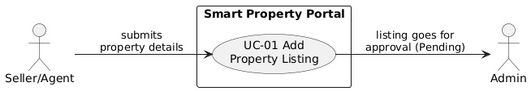
Field | Details
Use Case ID | UC-01
Use Case Name | Add Property Listing
Primary Actor | Seller / Agent
Secondary Actor(s) | Admin
Brief Description | A Seller/Agent fills property details (title, price, city, area, type, purpose, size, rooms, description) and uploads images. System stores the listing with status Pending, making it available for Admin review.
Trigger | Seller clicks Add Property from dashboard.
Preconditions | PRE-1: Seller/Agent is logged in. PRE-2: Seller profile contains valid contact info.
Post conditions | POST-1: Listing is created with status Pending. POST-2: Listing appears in Admin’s Pending section. POST-3: Images are saved in media storage.
Basic Flow | 1. Seller opens Add Property page. 2. System displays full listing form. 3. Seller enters all required property details. 4. Seller uploads one or more images. 5. Seller clicks Submit. 6. System validates all fields. 7. System saves listing as Pending. 8. Confirmation message shown.
Alternative / Exception Flows | AF-01: Missing/invalid fields → system highlights errors → seller corrects → return to step 5. AF-02: No images → system asks for at least one image → seller uploads and continues. E-01: Server/database error → listing not saved → system shows error. E-02: Session timeout → seller must log in again.
Business Rules / Assumptions | BR-1: Only Sellers/Agents may add listings. BR-2: Every new listing must start as Pending. BR-3: At least one image is required. A-1: Sellers provide accurate details.

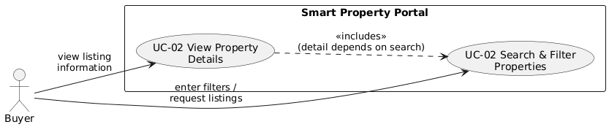
Use Case — UC-02
Field | Details
Use Case ID | UC-02
Use Case Name | Search & View Property Details
Primary Actor | Buyer
Secondary Actor(s) | None
Brief Description | Buyer searches using filters such as city, area, property type, purpose, and price range. System returns approved listings. Buyer selects one listing to view full details including images, map, description, and seller contact info.
Trigger | Buyer enters filters or clicks Search.
Preconditions | PRE-1: Listings exist in the system. PRE-2: Only Approved listings are visible.
Post conditions | POST-1: Search results displayed. POST-2: Property detail page opened.
Basic Flow | 1. Buyer opens search page. 2. Buyer selects filters and clicks Search. 3. System fetches matching approved listings. 4. System displays results. 5. Buyer selects a listing. 6. System displays full property details.
Alternative / Exception Flows | AF-01: No listings found → show “No properties found”. AF-02: Invalid price/size filters → system shows validation error → buyer fixes values. E-01: Server error fetching results → system displays error.
Business Rules / Assumptions | BR-1: Only Approved listings appear in search. BR-2: Filters must follow numeric and text validation rules. A-1: Buyer has internet access. A-2: Map loads successfully.

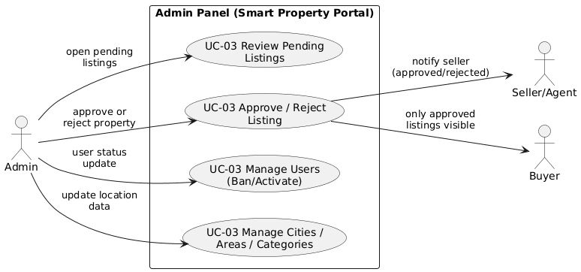
Use Case — UC-03

Field | Details
Use Case ID | UC-03
Use Case Name | Approve / Reject Property Listing
Primary Actor | Admin
Secondary Actor(s) | Seller / Agent
Brief Description | Admin reviews new property listings. Admin checks details & images, then Approves (listing becomes public) or Rejects (with remarks).
Trigger | Admin opens the Pending Listings page.
Preconditions | PRE-1: Admin is logged in. PRE-2: Listings exist with status Pending.
Post conditions | POST-1: Listing is updated to Approved/Rejected. POST-2: Seller receives notification. POST-3: Approved listings become publicly visible.
Basic Flow | 1. Admin logs into Admin Panel. 2. Admin opens Pending Listings. 3. System displays list of pending properties. 4. Admin selects a listing. 5. System shows details & images. 6. Admin clicks Approve or Reject. 7. System updates status. 8. Seller notified.
Alternative / Exception Flows | AF-01: Admin requests more info → listing marked Rejected with remarks. E-01: System error while saving status → admin sees error → status unchanged.
Business Rules / Assumptions | BR-1: Only Admin can approve/reject listings. BR-2: Rejected listings must include remarks. A-1: Admin manually checks authenticity.

3.4 Classes / Objects
This section contains the major logical classes that define the persistent data structure of the Smart Property Portal system.

3.4.1 Class / Object #1: Property Listing
3.4.1.1 Attributes
- listing ID (String, unique identifier)
- title (String)
- price (Number)
- city (String, links to City entity)
- area (String, links to Area entity)
- property Type (String, links to Category entity)
- status (String: 'Pending', 'Approved', 'Rejected')
- createdByUserId (String, links to User entity/Seller)
- images (Array of Image URLs)
- description (Text)
3.4.1.2 Functions
- create Listing(data, userId): Saves a new listing with status 'Pending' (Ref: FR-3.2.1).
- approve Listing(listingId): Sets status to 'Approved' (Ref: FR-3.2.3).
- search (filters): Returns listings where status='Approved' (Ref: FR-3.2.2).

3.4.2 Class / Object #2: User
3.4.2.1 Attributes
- userId (String, unique identifier)
- name (String)
- email (String, unique)
- phoneNumber (String)
- role (String: 'Buyer', 'Seller', 'Admin')
- status (String: 'Active', 'Banned')
- agencyDetails (Map/Object, for Seller/Agent only

3.4.2.2 Functions
- register(data): Creates a new user profile (Ref: Authentication Features).
- updateProfile(userId, data): Allows modification of user details (Ref: Authentication Features).
- banUser(userId): Sets user status to 'Banned' (Ref: Admin Management Features).

3.5 Non-Functional Requirements

3.5.1 Performance
- NFR-3.5.1.1 (Search Latency): The system shall load property search results within 2–3 seconds under normal conditions.
- NFR-3.5.1.2 (Page Load): 95% of public-facing webpages shall download completely and be usable within 4 seconds over a standard Internet connection.

3.5.2 Reliability
- NFR-3.5.2.1 (Fault Tolerance): The system shall handle invalid operations (e.g., trying to access a deleted listing) gracefully with appropriate error messages (e.g., "404 Not Found").
- NFR-3.5.2.2 (Data Integrity): The logic governing the public visibility of listings (Status='Approved') must be 100% accurate (Traceable to General Constraint 2.4(9)).

3.5.3 Availability
- NFR-3.5.3.1 (Uptime): The system shall remain accessible 24/7, excluding scheduled maintenance (Traceable to Operations 2.1.4).

3.5.4 Security
- NFR-3.5.4.1 (Authentication): The system shall use Django’s session-based authentication and protect all forms with CSRF tokens (Traceable to General Constraint 2.4(11)).
- NFR-3.5.4.2 (Authorization): The system shall enforce role-based access control (Admin-only access to approval dashboard; Seller-only access to edit/delete own listings) (Traceable to General Constraint 2.4(6)).
- NFR-3.5.4.3 (Privacy): User contact information must be stored securely and accessible only to the Admin or the Seller whose listing is being viewed (after approval).

3.5.5 Maintainability
- NFR-3.5.5.1 (Coding Standards): The system shall follow modular Django and React coding practices for simple updates and bug fixes (Traceable to General Constraint 2.4(7)).

3.5.6 Portability
- NFR-3.5.6.1 (Browser Compatibility): The system shall operate without modification on the latest stable versions of Chrome, Firefox, Edge, and Safari.
- NFR-3.5.6.2 (OS Compatibility): The system shall run on any operating system capable of hosting Django (Windows/Linux/Mac).

3.6 Inverse Requirements
- IR-3.6.1 (No Financials): The system shall explicitly not process financial transactions or integrate any payment gateways in this version (Traceable to DC-7).
- IR-3.6.2 (No Live Chat): The system shall not include a built-in live chat or instant messaging feature (Traceable to DC-7).
- IR-3.6.3 (No Automated Verification): The system shall not perform any automated property or seller verification; this is exclusively a manual Admin task (Traceable to Assumptions 2.5).

3.7 Logical Database Requirements
The database structure relies on the SQLite relational database. Key entities include:
- User: Stores all authentication and profile data (name, email, phone, role, status).
- Property: Core listing data (title, price, description, size, city_id, area_id, type_id, status, created_by_user_id).
- PropertyImage: Stores paths/references to uploaded image files, linked by property_id.
- City, Area, PropertyCategory: Managed by Admin, linked via foreign keys to the Property table.

